**Linux Assignment:**

1. Download the file [web_scraper.sh](https://hs2solutions-my.sharepoint.com/:u:/g/personal/sharath_ram_bounteous_com/EVjtybZVxKRHjRNAwDkxVIYB_IKgcXaEGaAEjgcYAnTC1Q?e=MwOOxC) . Make the file executable. The file takes any  wikipedia webpage as an argument. Run the process on multiple sites like [Wikipedia:Stub - Wikipedia](https://en.wikipedia.org/wiki/Wikipedia:Stub) , [India - Wikipedia](https://en.wikipedia.org/wiki/India) at the same time and
2. Find all the processes running on the system.
3. Find the first 5 processes with the highest memory usage.

Ans1:

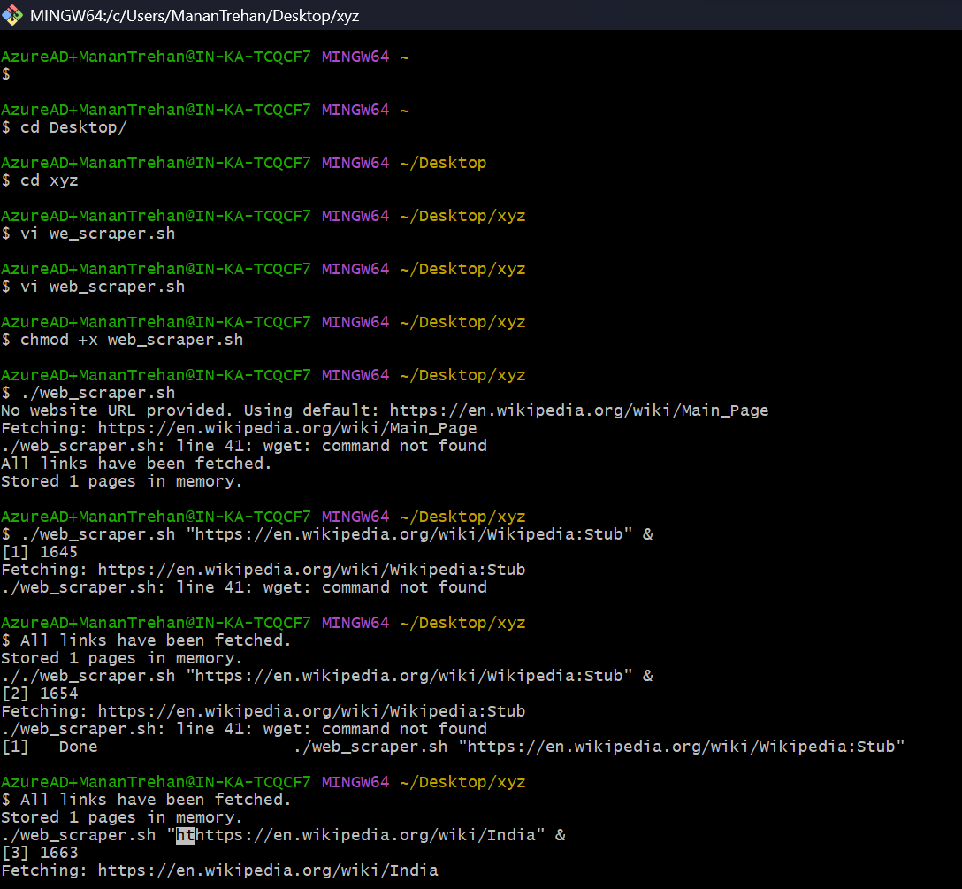

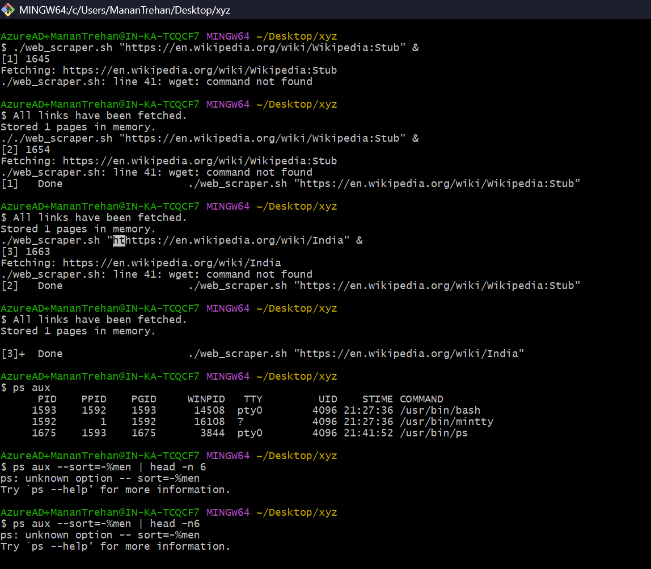

Print the HTTP response code obtained from google.com.

Ans2: 

Find the top 3 running processes which consume the most processing power.

Ans3: 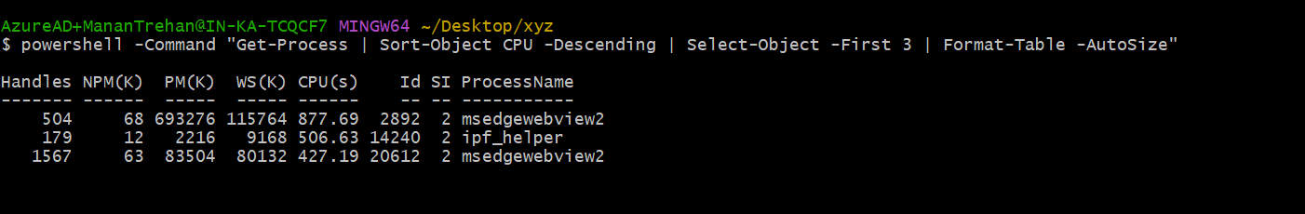

Write a script that finds all files larger than 100MB in a directory and lists them.

Ans4: 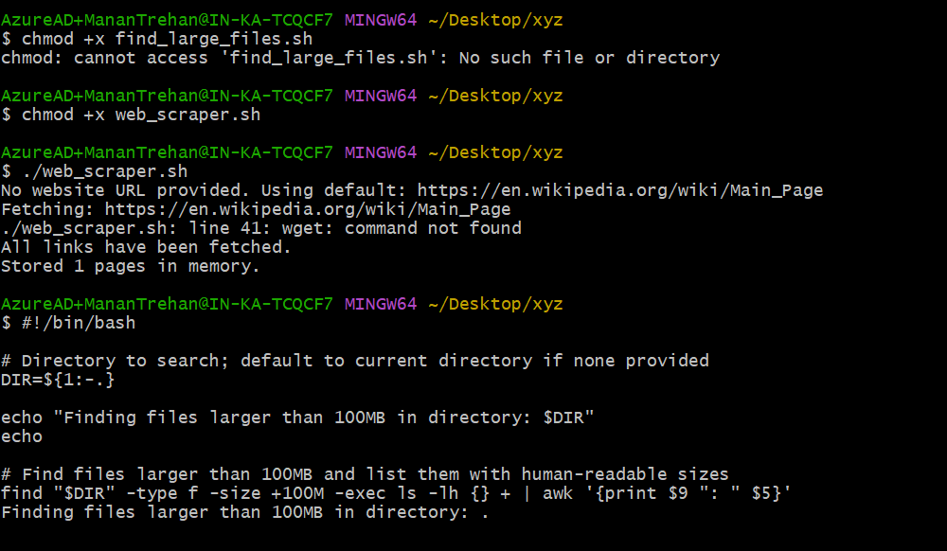

Find which version of Python is installed on the system.

Ans5: 

Get the current time zone of your system.

Ans6:

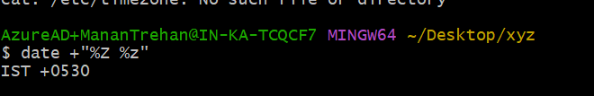

Get the current time in New York, London, and Sydney.

Ans7: 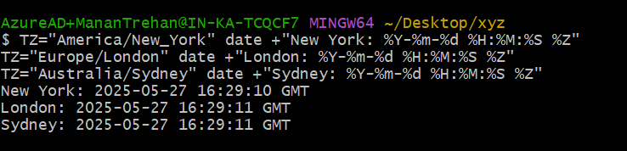

Check for how long the system is up.

Ans8: 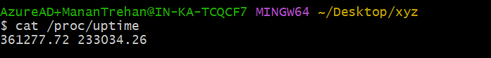

11.

a.

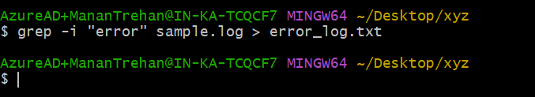

b.

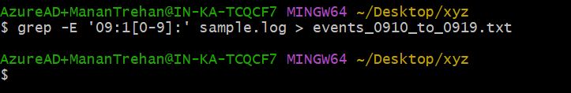

c.

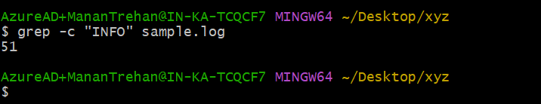

d.

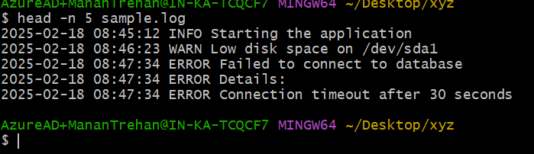

e.

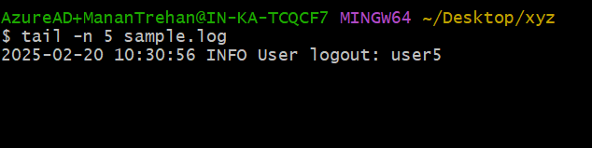

f.

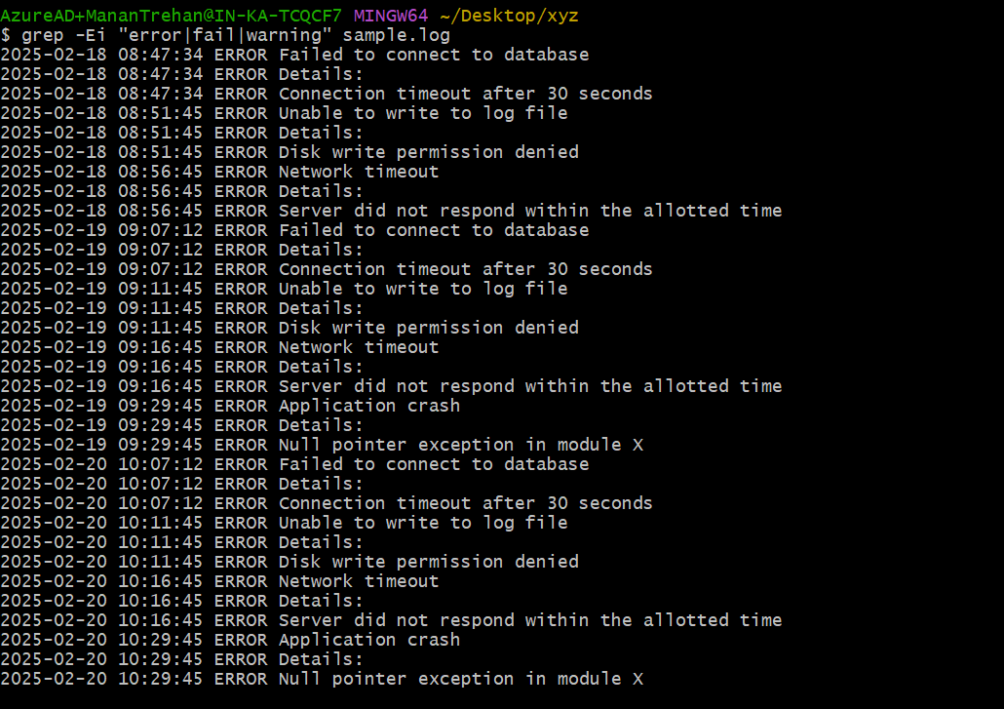

g.

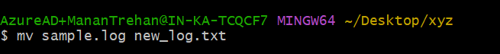

h.



i.



j.

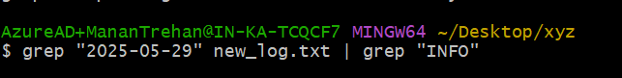

13.

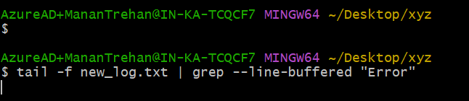

14.

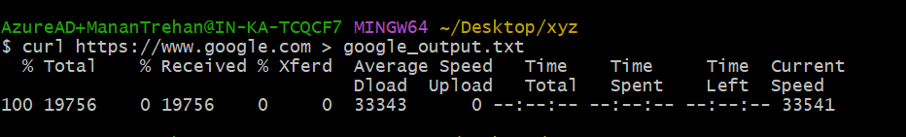

15.

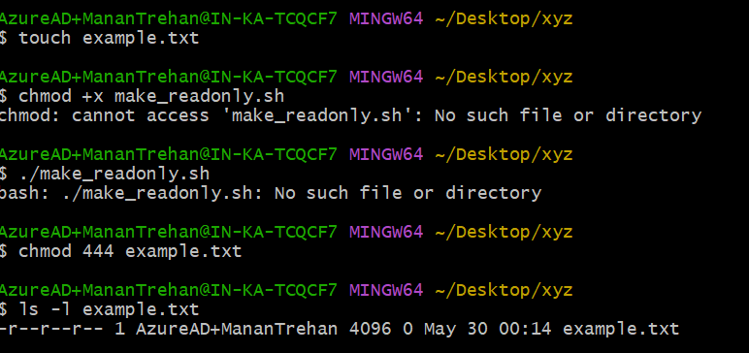

16.

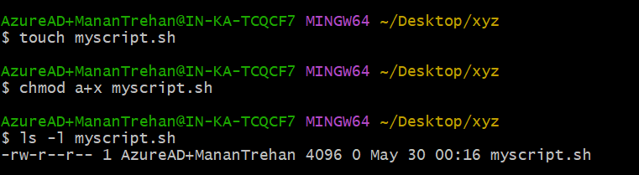

17.

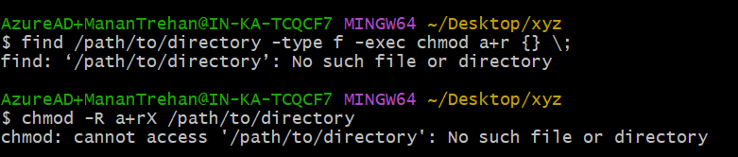

18.

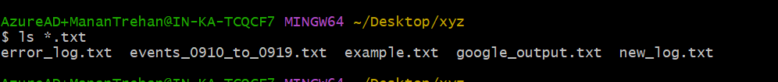

19.

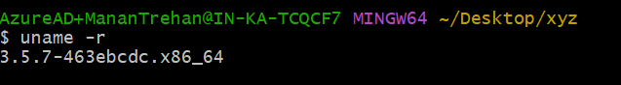

20.

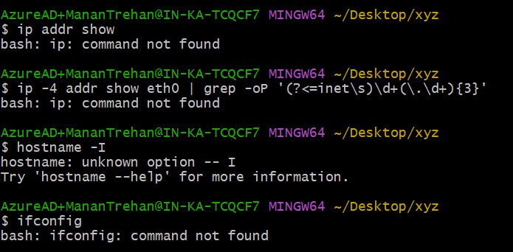

21.

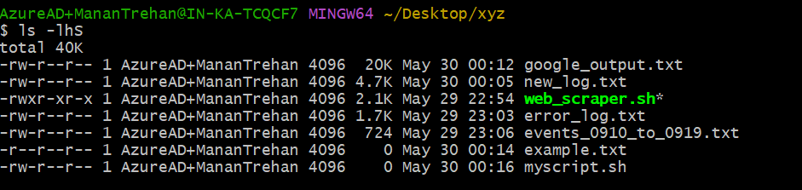

22.

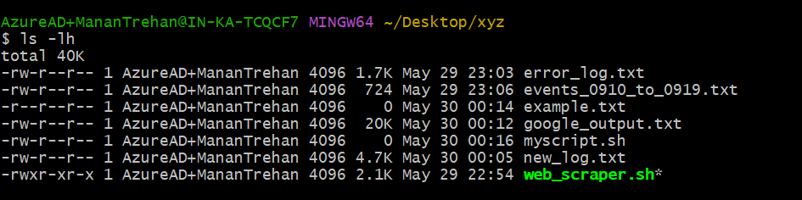

23.

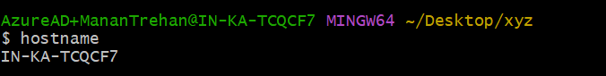

24.

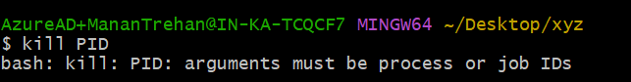

25.

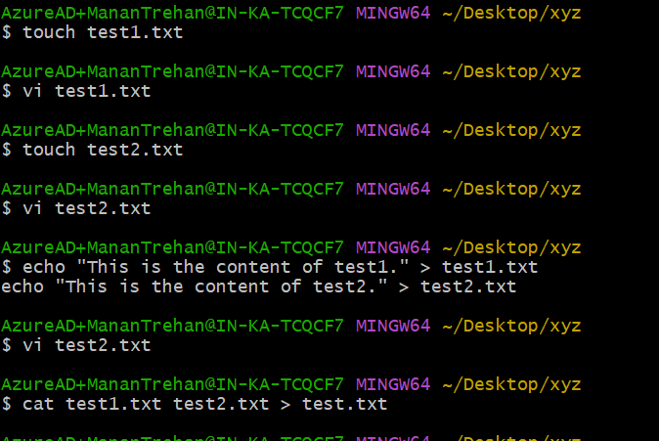

26.

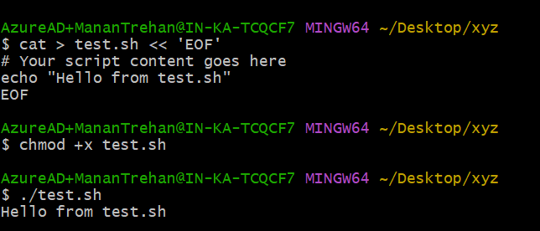

27.

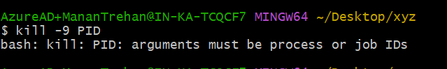

28.

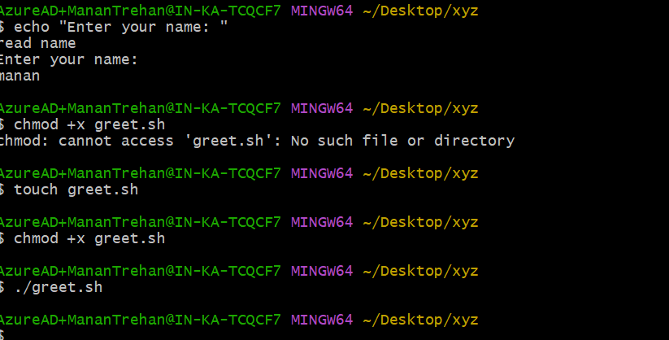

29.

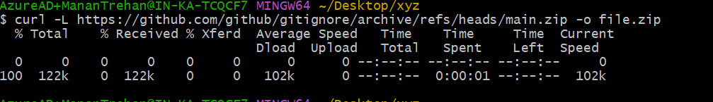

30.

